Show Your Love:
Preconception Health Campaign

Phase 2 Implementation Toolkit
April 2014

Table of Contents
Acknowledgments ii
Introduction 1
The Show Your Love Campaign 2
Step 1: Obtain Funding Support 2
Step 2: Outreach Plan 2
Appendix A: Sample Letter of Inquiry to Funding Organization 7
Appendix B: Sample Talking Points 9

List of Tables
No. Page
1 Organizations Prioritized as Potential Partners and/or Funders for Phase 2 4

Introduction

The Show Your Love Campaign
In Phase 1, 20 organizations implemented the Show Your Love campaign. Each organization developed its own partnership and dissemination plan and put this plan into action independent of the other organizations’ implementation efforts. In Phase 2, we hope to have organizations coordinate their planning, implementation, and evaluation efforts. A wider reach and stronger impact can be achieved if a larger and more diverse number of organizations implement the campaign and if media buys are funded and coordinated. To bring the campaign to this level, the Consumer Work Group (CWG) needs to take two main steps, which are described in the following sections.

Step 1: Obtain Funding Support
For Phase 2, funding is essential. There are multiple strategies that could be used to tackle the task of contacting organizations that might fund the campaign. Three possibilities are to
- Create a small working group of CWG members who will be responsible for contacting potential funders.
- Divide the responsibility among these CWG members. We have reviewed and prioritized 14 foundations and other funders whose missions align with the Show Your Love campaign (see Table 1). Each CWG member could be responsible for reaching out to three to five organizations. A sample letter of inquiry, which could be used to contact these funders, can be found in Appendix A.
- Hire a campaign coordinator who can devote time to this task. Applying for funding and setting up appointments to talk to potential funders take time, which is something that most CWG members do not have. CWG members could determine if there is one organization that would be able to hire a part-time campaign coordinator who could seek funding and partners, coordinate promotional activities, and facilitate discussions among organizations implementing the campaign. One possible scenario to make this happen is to have one organization from CWG hire and supervise the campaign coordinator and have other organizations contribute to paying that individual’s salary.

Step 2: Conduct Outreach
For the Show Your Love campaign to reach women across the country, a much larger base of organizations will need to be recruited to implement the campaign. New organizations could be recruited to be part of CWG or as implementation partners. A variety of different sectors of organizations should be recruited, including

- foundations,
- professional associations,
- retailers,
- pharmaceutical companies,
- businesses,
- service organizations, and
- media/entertainment organizations.
Ideally, the network would include organizations that collectively represent a range of sectors, such as those displayed in Figure 1.
The social marketing plan contains a long list of organizations that could be contacted for either funding or as implementation partners. Because this list is quite long, and the possibilities for partnering and funding are great, we reviewed this list and created a few priority organizations within each sector (see Table 1). We suggest that those who are conducting outreach for funding and partnership begin with, but not feel limited, to this list of organizations. A set of revised talking points can be found in Appendix B.
Figure 1. Phase 2 Campaign Partnership Network
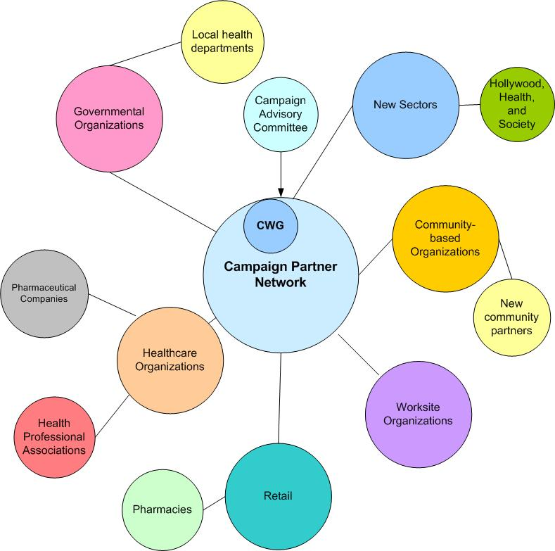
Table 1. Organizations Prioritized as Potential Partners and/or Funders for Phase 2
Organizational Type | Name of Organization | Available Contact Information | Role | Rationale for Prioritization
Foundation | The David and Lucile Packard Foundation  http://www.packard.org/grants/ | Tamara Krinin, Program Director for Population and Reproductive Health Program: 650-948-7658 | Funder | A key organizational mission is to provide access to reproductive health education. Funding application is available.
Foundation | W.K. Kellogg Foundation  http://www.wkkf.org/grantseekers | Joanne K. Krell, Vice President for Communications: 269-968-1611 | Funder | This organization emphasizes the prenatal months to age 8 as the foundation for all healthy development.
Foundation | The Dibble Institute for Marriage Education  http://www.dibbleinstitute.org | 1-800-695-7975 | Funder/  Partner | The focus of this organization is on adolescents, but it has a curriculum called Healthy Choices, Healthy Relationships.
Foundation | The William and Flora Hewlett Foundation  http://www.hewlett.org/grants/grantseekers | Contact not available | Funder | This organization currently funds Campaign to Prevent Teen and Unplanned Pregnancy.
Foundation | Irving Harris  http://www.irvingharrisfdn.org/ | mleary@irvingharrisfdn.org | Funder | The focus of this organization is on investments in early childhood.
Foundation | Abbott Fund  http://www.abbottfund.org/grants | Contact not available | Funder | Active partners include the American Cancer Society, the American Diabetes Association, and the Infant Welfare Society of Chicago.
Professional Association | American Academy of Physician Assistants (AAPA) http://www.aapa.org/ | Brooke Braun, VP Communications and External Relations: 571-319-4378 | Partner | This organization has several corporate partnerships. The most relevant is Lilly and Health Monitor whose mission is to facilitate the communication between patients, caregivers, doctors, and other health care professionals.
Professional Association | Association of Reproductive Health Professionals (ARHP) http://www.arhp.org/ | General number: 202-466-3825 | Partner | This organization has provider and patient resources on its Website. Although preconception health is not prominent, it may be an opportunity.
Professional Association | National Black Nurses Association (NBNA)  http://www.nbna.org/ | Millicent Gorham,  PhD (Hon), MBA, FAAN-  Executive Director  General number: 301-589-3200 | Partner | Several programs are aligned with preconception health behaviors (e.g., Obesity Initiative, Cardiovascular Health in Women Under 40, Diabetes).
Professional Association | Society for Public Health Education (SOPHE)  http://www.sophe.org/ | General number: 202-408-9804 | Partner | Several programs and initiatives are aligned with preconception health behaviors (e.g., The Smoking Cessation and Reduction in Pregnancy Treatment [SCRIPT] Program).
Professional Association | Society for Maternal-Fetal Medicine (SMFM) https://www.smfm.org/ | Daniel O'Keeffe, MD, Executive Vice President: 602-791-0176 | Partner | This organization partners with CDC, HRSA, FDA, MOD, Text4Baby, and NICHD.
Retail | Destination Maternity  http://www.destinationmaternitycorp.com/partnership.asp | Mike Catania,  Senior Vice President, Global Partner Businesses: 215-873-2316 | Funder or Partner | This organization sponsors the MOD Prematurity Campaign and partners with Buy Buy Baby, Enfamil, Huggies, and ViaCord.
(continued)
Table 1. Organizations Prioritized as Potential Partners and/or Funders for Phase 2 (continued)
Organizational Type | Name of Organization | Contact | Role | Rationale for Prioritization
Retail | Walgreens  http://www.walgreens.com/topic/about/company.jsp | General number:  1-800-925-4733 | Funder | Walgreens sponsors Vitamin Angels and offers Fertility Services. Funding application is available.
Pharmaceutical Companies | Hologic  http://www.hologic.com/en/about-hologic/hologic-story/ | Deborah Gordon- Vice President, Investor Relations  781-999-7716 | Funder | Hologic’s mission is women’s health; it sponsors MOD Prematurity and the Pearl of Wisdom Campaign. Funding application is available.
Pharmaceutical Companies | Johnson & Johnson  http://www.jnj.com/ | General number:  732-524-0400 | Funder | Johnson & Johnson sponsors Text4Baby, Baby Center, and other campaigns: http://www.jnj.com/caring/initiatives. Funding application is available. Note: Johnson & Johnson "does not accept unsolicited requests for funding" and does "not respond to form letters or e-mail campaigns.”
Pharmaceutical Companies | Pfizer  http://www.pfizer.com/ | General number:  212-733-2323 | Funder | Pfizer sponsors Text4Baby and The National Campaign to Prevent Teen and Unplanned Pregnancy. Funding application is available. Note: Pfizer's Corporate Responsibility department and The Pfizer Foundation do not accept unsolicited requests for support.
Business | Employee Health Care Alliance Cooperative http://www.the-alliance.org/ | Teri Van Tassel  Vice President, Marketing & Member Services: Main switchboard: 608-276-6620 | Partner | The BabyLove program offers pregnancy resources: http://www.the-alliance.org/consumers/babyLove_-_pregnancy_education/
Business | What to Expect…  http://www.whattoexpect.com/what-to-expect/landing-page.aspx | None specific: NY/Headquarters: 646-728-9500 | Partner | This organization partnered with Medela, Cord Blood Registry, Babies R Us, Similac, and the What to Expect Foundation (http://www.whattoexpect.org/contact-us), which has numerous national partners ranging from YMCAs to health care organizations.
Business | Wellpoint  http://www.wellpoint.com/ | None specific: Corporate Headquarters: 317-488-6000 | Funder | Wellpoint plays a leadership role in women's health: wellness and prevention, disease management, quality improvement, and community involvement. It sponsors Text4Baby. Funding application available.
Business | Care First: Blue Cross Blue Shield  https://member.carefirst.com/individuals/home.page | Email community.affairs@carefirst.com | Funder | Care First sponsors Text4Baby. Funding application is available.
Business | Dove (Unilever Brands)  http://www.dove.us/ | For media relations: Stacie Bright, Unilever:  201-894-6531 | Partner | Dove sponsors the Dove Real Beauty Campaign and Girls Self Esteem.
Service Organization | American Pregnancy Association  http://americanpregnancy.org/ | info@americanpregnancy.org | Partner | This organization has an ovulation calculator on its home page and disseminates an e-newsletter by week of pregnancy.
Service Organization | National Birth Defects Prevention Network  http://www.nbdpn.org/ | nbdpn@nbdpn.org | Partner | This organization sponsors National Birth Defects Prevention Month.
(continued)
Table 1. Organizations Prioritized as Potential Partners and/or Funders for Phase 2 (continued)
Organizational Type | Name of Organization | Contact | Role | Rationale for Prioritization
Service Organization | National Council on Folic Acid  http://www.folicacidinfo.org/ | 800-621-3141 | Partner | This organization sponsors National Folic Acid Awareness Week and provide educational materials on its Website.
Service Organization | American Cancer Society  www.cancer.org | Contact not available | Partner | This organization sponsors the Great American Smokeout.
Service Organization | National Council on Alcoholism and Drug Dependence, Inc.  http://www.ncadd.org/index.php/ | Jayne Restivo, Director of Development  212-269-7797 ext. 15 | Partner | This organization sponsors National Alcohol Awareness Month.
Media/  Entertainment | Hollywood Health and Society  http://hollywoodhealthandsociety.org/ | hhs@usc.edu | Partner | This organization could help identify a possible spokesperson.
Media/  Entertainment | Babycenter  http://www.babycenter.com/ | Contact not available | Partner | This organization has a major tab on its Website devoted to getting pregnant, including “get your body ready.”
Media/  Entertainment | http://mothersover35.com/ | http://mothersover35.com/contact-us/ | Partner | This organization would be a target audience for interconception health.

Appendix A: Sample Letter of Inquiry to Funding Organization

[Insert Date]
[Insert Contact Information for Foundation]
[Contact Name]
The goal of the SYL campaign is to increase the proportion of women who plan in advance when to become pregnant and engage in PCH behaviors prior to becoming pregnant.
Campaign messages focus on increasing awareness, knowledge, motivation, and favorable attitudes toward PCH.

[Position]
[Address]
Dear [Insert Contact Name]:
On behalf of [insert organization’s name], I am writing to introduce an important health promotion campaign to enhance the health of women and babies. Show Your Love is an innovative, evidence-informed, campaign designed for women of reproductive age. The Campaign is seeking to elevate preconception health, which is a woman’s health before she gets pregnant, to the same level of awareness and significance as prenatal health.
Improving health before pregnancy is commonly referred to as preconception health. Promoting preconception health includes addressing a bundle of lifestyle behaviors, chronic conditions, and services that includes quitting smoking, obtaining up-to-date immunizations, avoiding alcohol, and maintaining a healthy weight, among others. Evidence increasingly shows that improving women’s health before pregnancy is important for optimizing pregnancy outcomes, including the prevention of birth defects.
A pilot of Show Your Love was launched in 2013 to great success. A public-private partnership consisting of the Centers for Disease Control and Prevention and leaders in the field of maternal and child health, such as Planned Parenthood and March of Dimes, collaborated voluntarily to address this important public health issue. The partnership produced and disseminated audience-tested campaign materials and messages for different groups of women. Launched primarily via social media, the campaign had over two million social media impressions. The evaluation of this pilot showed that organizations could easily implement the campaign. With additional support from organizations, Show Your Love could reach millions of women across the United States and increase their awareness of the importance of preconception health. The goal of the campaign is to improve the health of women and decrease the risk of birth defects in children.
Based on the success of the pilot, we are ready to launch a national Show Your Love campaign, and as such I am writing to inquire about the possibility of funding from [insert foundation]. We are hoping to launch the national campaign in 2015, and your support would allow the campaign to reach more women by including mass media and advertising and a much greater impact. Please let me know if there is a possibility for such funding through your organization and if I can provide any additional information by submitting an official grant application to [insert foundation].
Sincerely,
[Insert name]

Appendix B: Sample Talking Points

What is Show Your Love?
- An innovative, evidenced-based, social marketing campaign targeting women of reproductive age.
- Campaign mission: To elevate preconception health (PCH) - a woman’s health before she gets pregnant- to same level of awareness and significance as prenatal health.
What is preconception health? Why is it important?
- PCH is improving health before pregnancy and addresses a bundle of lifestyle behaviors, chronic conditions, and services that include quitting smoking, obtaining up-to-date immunizations, avoiding alcohol, maintaining a healthy weight, among others.
- Evidence shows improving women’s health before pregnancy is important for optimizing pregnancy outcomes, including prevention of birth defects.
What has Show Your Love accomplished thus far?
- Pilot launched in 2013 by a public-private partnership consisting of volunteers from the Centers for Disease Control and Prevention and leaders in the field of maternal and child health- e.g., March of Dimes and Planned Parenthood
- Launched primarily via social media: disseminated audience-tested campaign materials and messages. Materials included health e-cards, video PSAs, posters, web buttons, and checklists.
- Participating organizations (aka: campaign implementers) have: Posted messages on social media, displayed buttons and banners on their web sites, linked from their web sites to CDC’s web site, sent campaign information through listservs, featured the campaign in newsletters and on radio shows, distributed press releases, presented information about the campaign at meetings and trainings, personal outreach, and played SYL videos in health care providers’ waiting rooms.
- Campaign presence on YouTube, Twitter, FaceBook and Pinterest. Over two million social media impressions
- Process evaluation found campaign launch successful and positive feedback received from target audience
What is planned for Phase 2?
- We are planning to launch the national SYL campaign in 2015 with an expanded partner network and with that disseminate exciting and innovative campaign via mass media and advertising.

Why [organization] is a good fit? [note: tailor according to individual organization—see Rational for Prioritization column in Phase 2 Toolkit document]

- We are seeking a strong network of partners and funding organizations to help us take SYL to the next level. Your organization’s reputation as a trusted source of health information for women can draw attention to the campaign and increase the credibility of its messages.
[For Potential Partners] The ‘ask’
- Your support will greatly help SYL reach many more women. We would like to invite you join our mission and serve as an official SYL campaign partner. Please let me know if [insert organization] would be interested in participating as a campaign partner.
[For Potential Funders] The ‘ask’
- Your support will greatly help SYL reach many more women. Campaign contributions will allow for the development of new products and innovative ways to disseminate through mass media and advertising. Please let me know if there is a possibility of funding from [insert organization] to help us meet our goals. We are more than happy to provide more information (and if applicable) submit an official grant application.

